|  |
| --- |
| Japanese in New York  Macintosh HD:private:var:folders:pd:7b91nd3j4gsckxrp2x4mt2hh0000gn:T:TemporaryItems:cb3c0x-2.jpg |
| Coursera Capstone: IBM Data Science Course  Paula Maldonado  August 2020 |

# **Introduction**

New York City's demographics show that it is a large and ethnically diverse metropolis. It is the largest city in the United States with a long history of international immigration. New York City was home to nearly 8.5 million people in 2018. It accounted for over 40% of the population of New York State and a slightly lower percentage of the New York metropolitan area, home to approximately 23.6 million. Over the last decade, the city has been growing faster than the region. The New York region continues to be the leading metropolitan gateway for legal immigrants admitted into the United States. This final project explores the best locations for Japanese restaurants throughout the city of New York. Potentially the owner of the new Japanese restaurant can have great success and consistent profit. However, as with any business, opening a new restaurant requires serious consideration and is more complicated than it seems. In particular, the restaurant's location is one of the most critical factors that will affect whether it will have success or failure. So our project will attempt to answer the questions "Where should the investor open a Japanese Restaurant?" and "Where should I go if I want great Japanese food?"

# **Business Problem**

# The objective of this Capstone project is to analyze and select the best locations in the city of New York to open a new Japanese restaurant. Using Data Science methodology and instruments such as Data Analysis and Visualization, this project aims to provide solutions to answer the business question: Where in the city of New York, should the investor open a Japanese Restaurant?

# **Target Audience**

# This project is particularly useful to developers and investors looking to open or invest in a Japanese restaurant in New York. Overall, New York is a great place to open a restaurant with ethnic cuisine. New York is the most diverse city, globally. With its diverse culture, comes diversity in the food items. There are many restaurants in New York City, each belonging to different categories like Chinese, Indian, French, and more. Why did we decide to focus on Japanese cuisine in our project? Now when the idea of a healthy lifestyle conquered the minds of people all over the country, Japanese restaurants became extremely popular, as they offer a healthy alternative to regular American eating habits.

# **Data**

# To solve the problem, we will need the following data: New York City data containing the neighborhoods and boroughs. •

# Latitude and longitude coordinates of those neighborhoods, which are required to plot the map and get the venue data.

# Venue data related to restaurants. We are going to use this data to perform further analysis of the neighborhoods.

## Data Source and methodology

New York City data containing the neighborhoods and boroughs will be obtained from the open data source: https://cocl.us/new_york_dataset.

* Data will be collected from https://cocl.us/new_york_dataset and cleaned and processed into a dataframe.
* FourSquare be used to locate all venues and then filtered by Japanese restaurants. Ratings, tips, and likes by users will be counted and added to the dataframe.
* Data will be sorted based on rankings.
* Finally, the data will be visually assessed using graphing from Python libraries.

## Results

The results of our analysis showed below:

**1. We see that Queens has the highest number of Neighborhoods.**

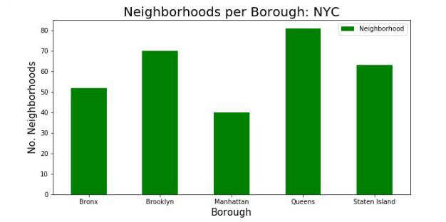

**2. Although Manhattan had the least number of neighborhoods, it does have the highest number of Japanese restaurants.**

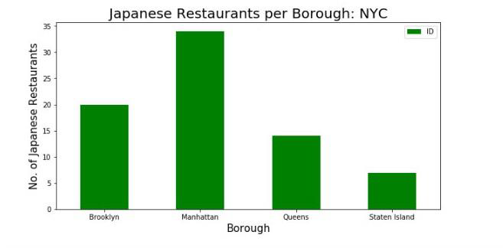

**3. The Murray Hill in Manhattan has the highest number of Japanese Restaurants with a total count of 5.**

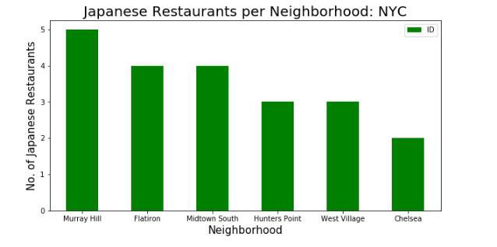

**4. Manhattan has the highest average rating for Japanese Restaurants. Brooklyn goes right behind the Manhattan with the average rating of its Japanese restaurants only a little lower than Manhattan. Two neighborhoods with the highest average rating for Japanese Restaurants are Cobble Hill and North Side (both located in Brooklyn).**

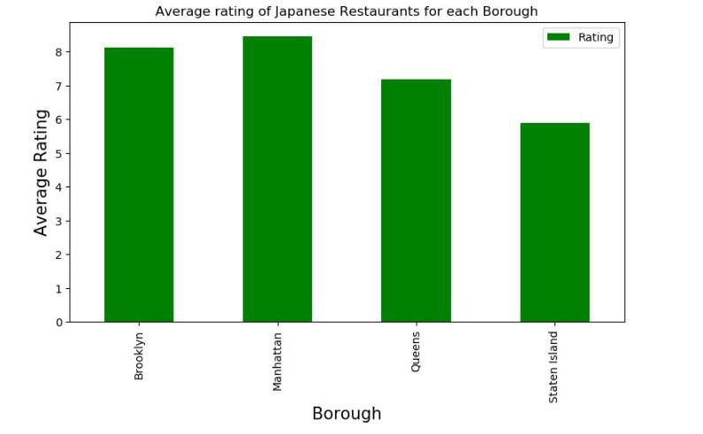

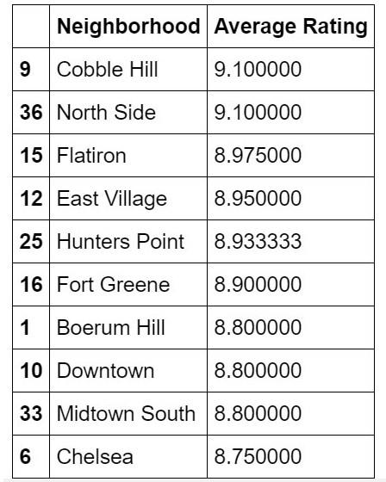

**Top Ten neighborhoods with Japanese Restaurants with the best average rating**

## Discussion Section

Based on the results of our analysis, I would state that Manhattan and Brooklyn are the best locations for Japanese cuisine in NYC. To have the best shot of success, I would open a Japanese restaurant in Brooklyn. Brooklyn has multiple neighborhoods with average ratings exceeding 8.0 on a scale of 1.0 to 10.0 and has less amount of Japanese restaurants than Manhattan, making competition easier. In addition, we should keep in mind that real estate prices in Brooklyn are much cheaper than in Manhattan. Particularly, I would recommend considering opening a Japanese Restaurant either in Cobble Hill or in North Side, because both of these neighborhoods have the highest rating for Japanese restaurants.

## Limitations and suggestions for future researches

All of the above analysis is depended on the accuracy of Four Square data. Besides, during this project, we used a free Sandbox Tier Account of Foursquare API that goes with limitations as to the number of API calls and results returned. To get better results, future research work and more comprehensive analysis could consider using a paid account to bypass these limitations as well as incorporating data from other external databases.

## Conclusions

In the project we have gone through the process of identifying the business problem, specifying the data required, extracting and preparing the data, performing data analysis, and lastly providing recommendations to the investors/developers. During the project, we applied different data science methods and instruments to get the answer to our main question: “Where in the City of New York, should the investor open a Japanese Restaurant?” The findings of this project will help the relevant investor better understand the advantages and disadvantages of different New York neighborhoods/boroughs in terms of opening a Japanese restaurant.